Project Design Phase-II

Data Flow Diagram & User Stories

Date | 8 December 2025
Team ID | SWUID60312
Project Name | Medifolio - Doctor Appointment Booking system
Maximum Marks | 4 Marks

Data Flow Diagrams:
A Data Flow Diagram (DFD) illustrates how data moves within the Medifolio Doctor Appointment Booking System. It shows how users, doctors, and admins interact with the system, how information flows between different processes, and where the data is stored.


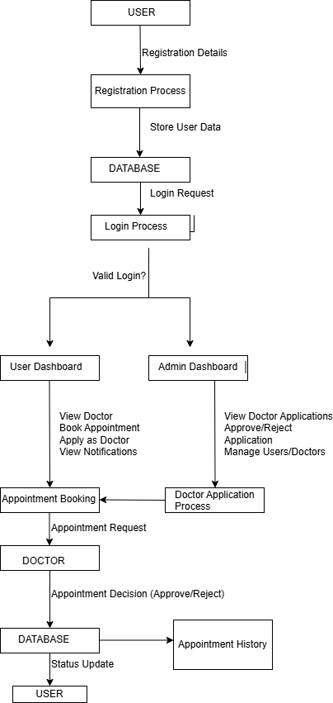

User Stories
User Story Table –Medifolio (Doctor Appointment Booking System)

User Type | Functional Requirement (Epic) | User Story / Task | Acceptance Criteria | Priority | Release
User | Registration | nt to register with my details so that I can cre | User account is created successfully and stored in the database. | High | Sprint-1
User/Admin | Login | As a user/admin, I want to log in securely so that I can access my dashboard. | Login is successful and redirects to the correct dashboard. | High | Sprint-1

User | View Doctors | As a user, I want to view a list of approved doctors so that I can choose one. | Approved doctors appear clearly on the dashboard. | High | Sprint-1
User | Book Appointment | As a user, I want to book an appointment with a doctor so that I can visit at my preferred time. | Appointment is saved, and user receives a confirmation notification. | High | Sprint-1
User | Upload Documents | As a user, I want to upload a document during booking if needed. | Uploaded document is linked to the appointment. | Medium | Sprint-2
User | Apply as Doctor | As a user, I want to apply to become a doctor on the platform. | Application is submitted and visible to the admin for review. | Medium | Sprint-2
Admin | Review Doctor Applications | As an admin, I want to review doctor applications so that I can approve or reject them. | The doctor’s status updates immediately after decision. | High | Sprint-1

Admin | Manage Doctors | As an admin, I want to approve/reject doctor profiles so that the system stays validated. | Approved doctors appear to users; rejected ones do not. | High | Sprint-1
Admin | Manage Users | As an admin, I want to view all registered users so that I can monitor platform usage. | User list loads successfully. | Medium | Sprint 2
Doctor | Manage Schedule | As a doctor, I want to update my available time slots so that users can book correctly. | Users see updated availability instantly. | High | Sprint 1
Doctor | Approve/Reject Appointments | As a doctor, I want to approve or reject appointment requests. | User receives notification of  doctor’s decision. | High | Sprint 1
User | View Notifications | As a user, I want to receive notifications about appointment status. | Notifications appear instantly in dashboard. | High | Sprint 2
User | Appointment History | As a user, I want to see my past and upcoming appointments. | History loads with correct details. | Medium | Sprint 2

